Lab Assignment:

1. Design subnets for three LANs with constraints:

The available IP address space is the range 10.10.172.0-10.10.172.255. You may only assign IP addresses in this range

LAN A must be able to support at least 50 hosts.

LAN B must be able to support at least 75 hosts.

LAN C must be able to support at least 20 hosts.

For each subnet, identify:

1. Subnet Mask;
2. Network Address;
   1. This will be the bitwise AND of the IP address of any host on the network and the subnet mask
3. Smallest IP address that may be assigned to a host in the subnet (host number 1);
   1. This is the gateway address, plus 1.
4. Broadcast address for the subnet;
   1. This is the bitwise OR of the network address and the inverse of the subnet mask
5. Highest IP address that may be assigned to a host in the subnet;
   1. This is the broadcast address, minus 1.
6. Complete following table:

|  |  |  |  |  |  |  |
| --- | --- | --- | --- | --- | --- | --- |
| Hosts | Subnet Mask | Network Address | Smallest host address | Highest host address | Broadcast address | notes |
| LAN A:  Jim & Pam | 255.255.255.192 | 10.10.172.128 | 10.10.172.130 | 10.10.172.190 | 10.10.172.191 | Support at least 50 hosts |
| LAN B:  Michael & Dwight | 255.255.255.128 | 10.10.172.0 | 10.10.172.2 | 10.10.172.126 | 10.10.172.127 | Supports at least 75 hosts |
| LAN C:  Andy & Kevin | 255.255.255.224 | 10.10.172.192 | 10.10.172.194 | 10.10.172.222 | 10.10.172.223 | Support at least 20 hosts |

Provide outputs of the following:

1. Network interface configuration:

Provide screenshot of ifconfig ethl on each of the six hosts

Andy:

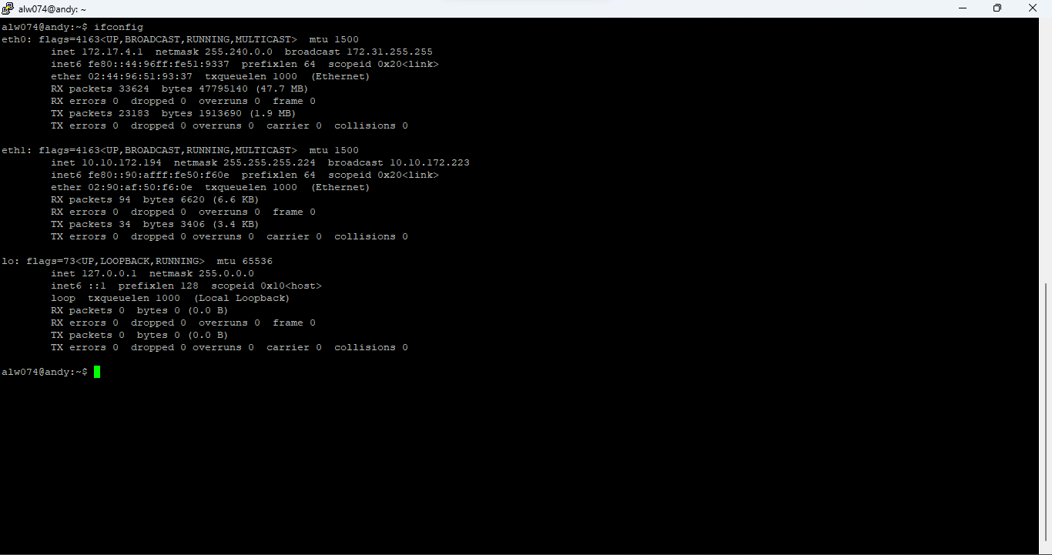

Kevin:

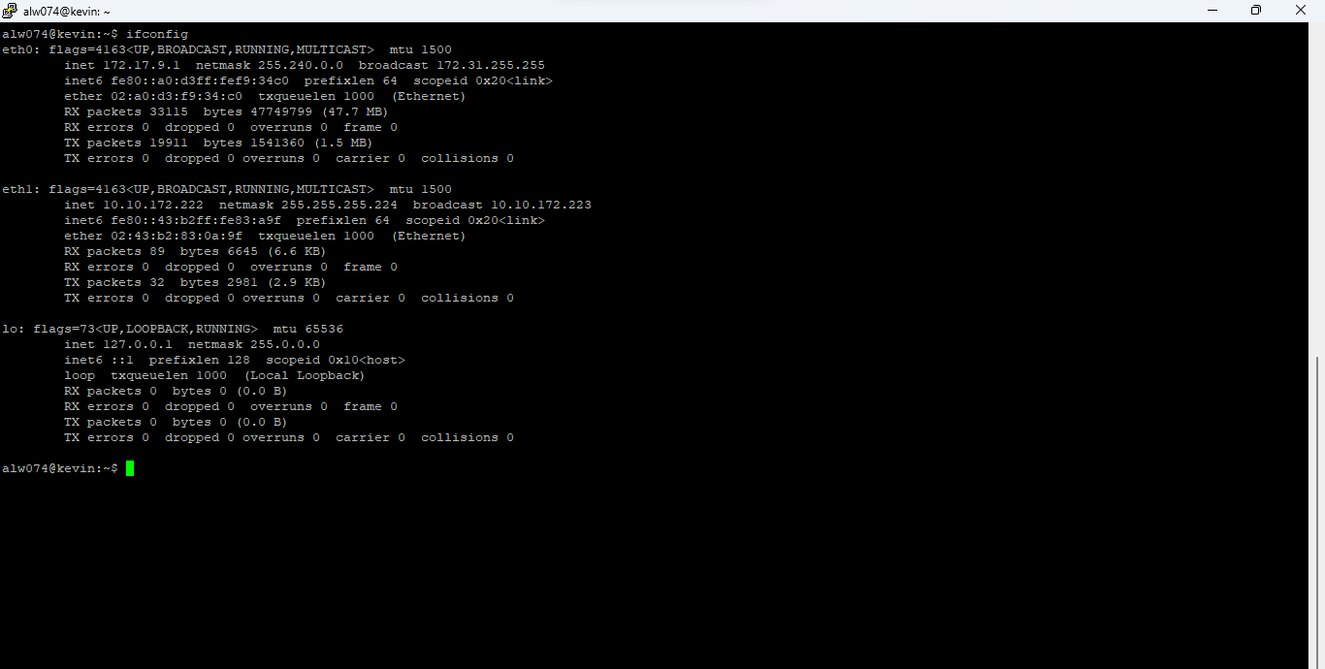

Dwight:

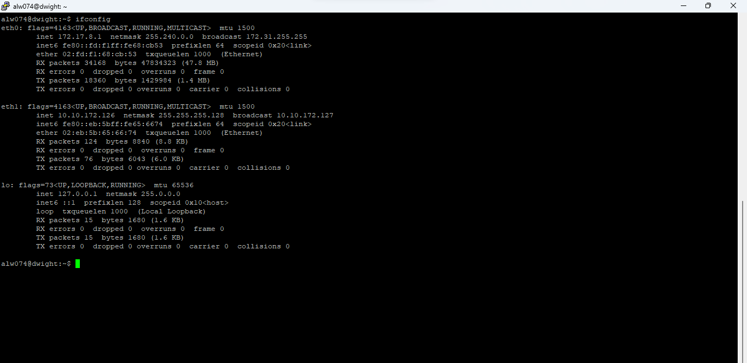

Michael:

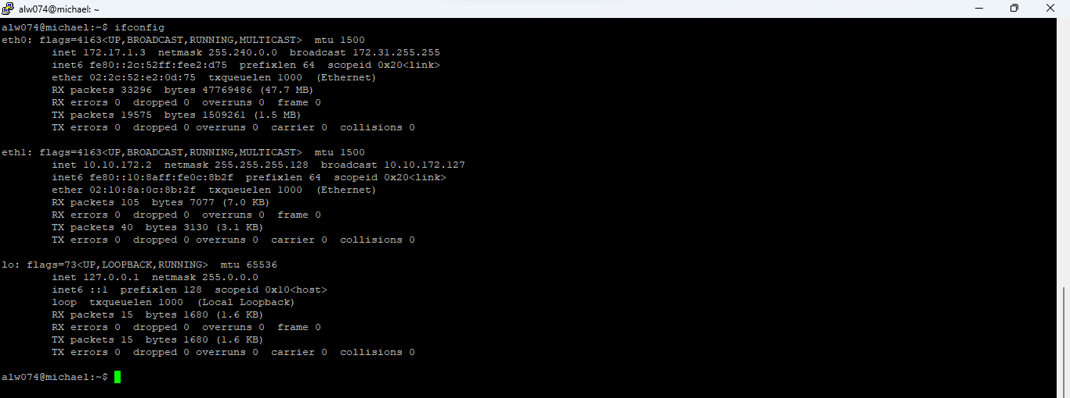

Pam:

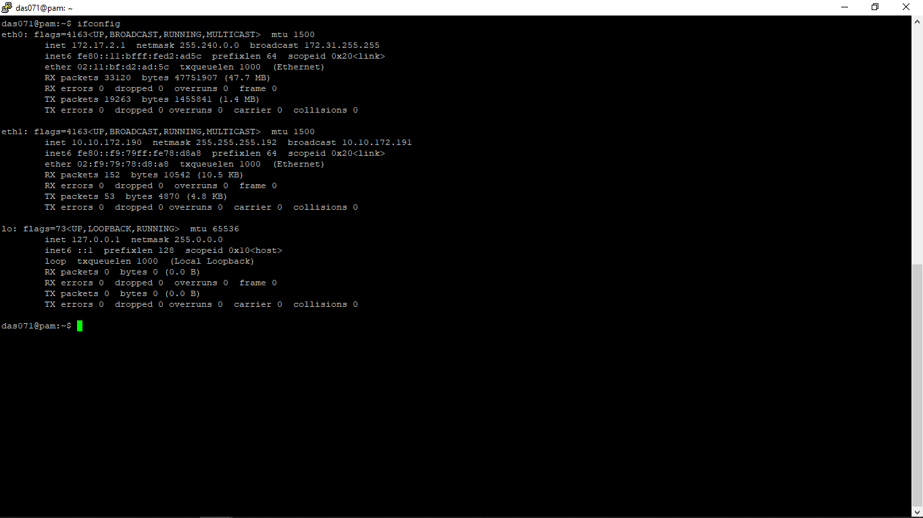

Jim:

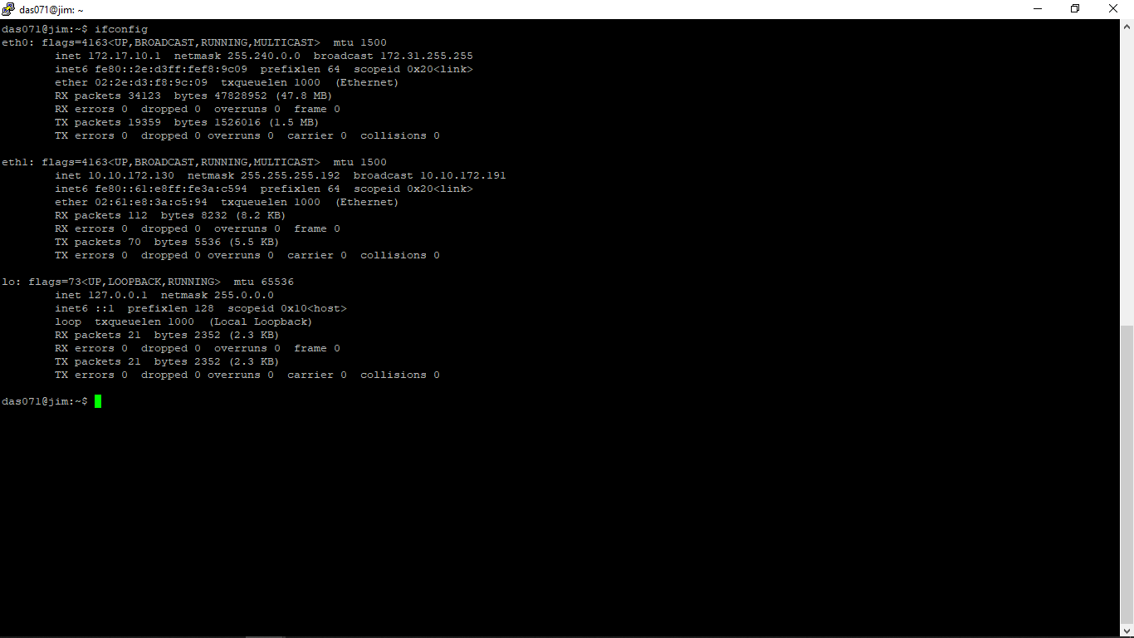

Provide screenshot of ifconfig on each router

Router A:

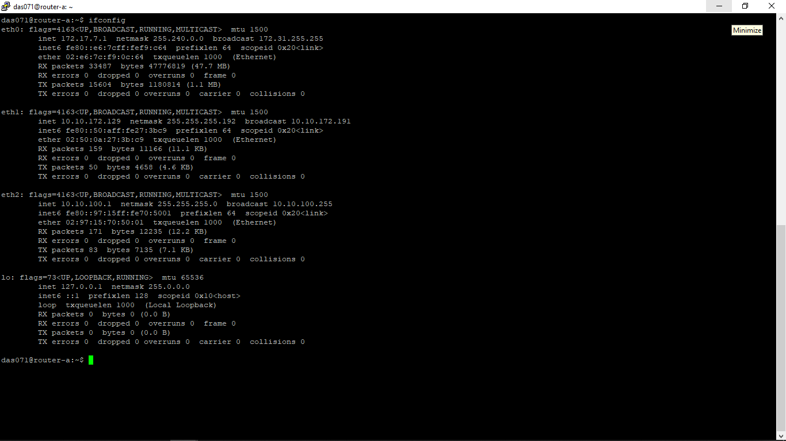

Router B:

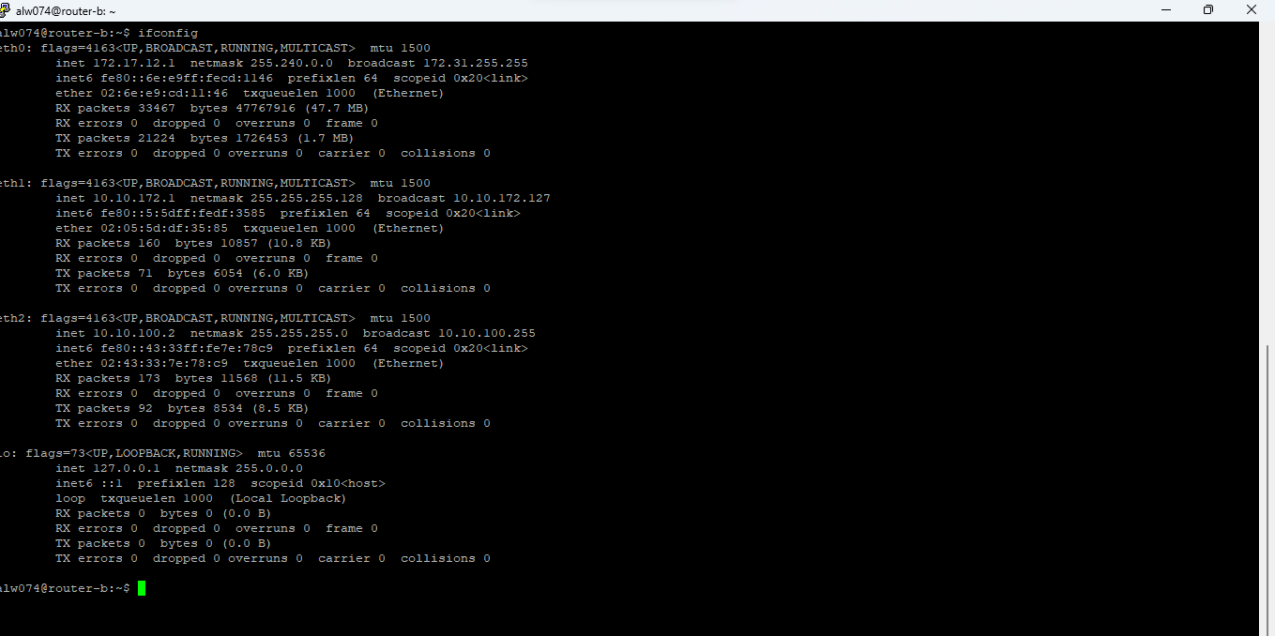

Router c:

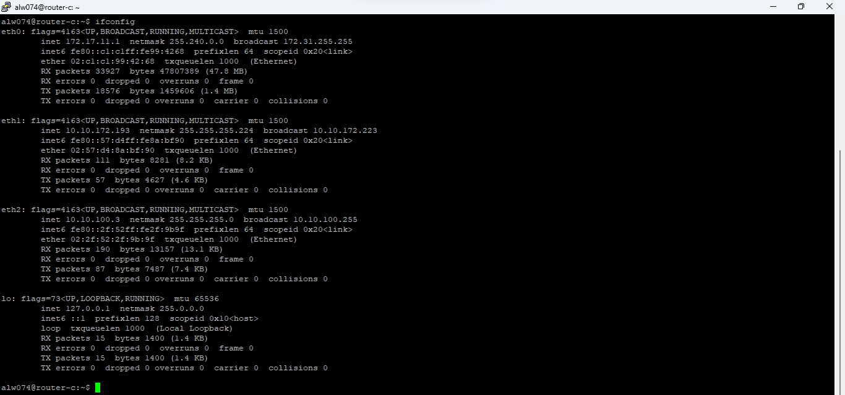

1. Routing within and between subnets

Provide the output of route -n on the “jim” host

Annotate the output to indicate:

* Which rule will apply to traffic from ‘jim’ to “pam”
* For Michael
* Dwight
* Andy
* Kevin

1. Show the output of traceroute from ‘jim’ to each of the five other hosts

Run the traceroute command five times, with a different destination IP address each time, and provide the screenshot of the output each time. Indicate which host is the destination in each case.